PROJECT REPORT

Page 1

TERNA PUBLIC CHARITABLE TRUST’S
TERNA POLYTECHNIC
SEC-1, KOPARKHAIRANE, NAVI MUMBAI-400701
CERTIFICATE
Certified that this report submitted by
Shri/Kum
Roll.No. a student of third year of course “ELECTRONIC & TELECOMMUNICATION” as a part of project work as described by the Maharashtra Board of Technical Education .

For the Project “CELL PHONE OPERATED LAND
ROVER”

And that I have instructed/guided him for the said work from time to time and I found him to be satisfactory progressive.
And that following student was associated with him for his work. However his contribution was proportionate.
And that the said work has been assessed by me and I am satisfied that the same is upto the standard envisaged for the level of the course
And that the said work may be presented to external examiner

DATE:

PROJECT GUIDE HEAD OF DEPARTMENT

EXTERN AL PRINCIPLE
Page2

TERNA PUBLIC CHARITABLE TRUST’S
TERNA POLYTECHNIC
SEC-1, KOPARKHAIRANE, NAVI MUMBAI-400701
CERTIFICATE
This is to certify that following report submitted by the following student of third year of course “ELECTRONIC & TELECOMMUNICATION” as a part of seminar/project work as prescribed by the board of technical education for the subject “CELL PHONE OPERATED LAND ROVER ” . And that I guided him for the term work from time to time and I found him to be satisfactory progressive.
And that following student were associated with him for his work however his contribution was proportionate.
NAME CLASS DIV ROLL.NO
Gaurav A.Khadasane TYEJ E 06
Tejas Jethwa TYEJ E 05
Suraj Terde TYEJ E 11
Akshay Sonawale TYEJ E 12

And that the term work has been assessed by me and I am satisfied that the same is upto the standard envisaged for the level of the course. And that the team work may be presented to external examiner
DATE:

PROJECT GUIDE HEAD OF DEPARTMENT

EXTERNAL PRINCIPAL
PAGE 3

TERNA PUBLIC CHARITABLE TRUST’S
TERNA POLYTECHNIC
SEC-1, KOPARKHAIRANE, NAVI MUMBAI-400701
SUBMISSION
We hereby declare that student of third year of course “ELECTRONIC & TELECOMMUNICATION” kindly submit that we have completed from time to time the seminar/project work as described in this report by our own skill and between the period from to as per the guidance of MRS. A.R.KULKARNI
For the subject “CELL PHONE OPERATED LAND
ROVER”
And the following student were associated with us for this work however quantum of our contribution has been approved by teacher

NAME CLASS DIV ROLL.NO
GUARAV A.KHADASANE TYEJ E 06
TEJAS JETHWA TYEJ E 05
SURAJ TERDE TYEJ E 11
AKSHAY SONWALE TYEJ E 12

Name Of Student:

Date: Sign of student

Page 4

INDEX Page No.

1. PREFACE

A) INTRODUCTION………………………………………………………

B) HISTORY……………………………………………………………………………..

C) TECHNOLOGY USED (DTMF SIGNALLING)………………………

2. DESIGN OF THE PROJECT

A) PRELIMINARY DESIGN

i) BLOCK DIAGRAM…………………………………………….

ii) COMPONENTS USED……………………………………

iii) CIRCUIT DIAGRAM…………………………………………..

B) PROBLEMS ENCOUNTERED………………………………………...

C) FINAL DESIGN

- PCB LAYOUT………………………………………………
- PROGRAM CODE……………………………………..
iii) FLOWCHART……………………………………………..

Page 5
D) SOFTWARES USED i) PINACAL…………………………………………………….
ii) ISP Programmer........................................................................

3. SCOPE OF THE PROJECT

1. APPLICATIONS……………………………………………..
2. ADVANTAGES……………………………………………...
3. DISADVANTAGES…………………………………………. 4. FURTHER IMPROVEMENTS & FUTURE SCOPE………...

4. BIBLOGYAPHY…..…………………………

5. DATASHEETS……………………………………

Page 6

ACKNOWLEDGEMENT

We feel profound pleasure in bringing out this projects report for which we have to go from pillar to post to make it a reality. This project work reflects contributions of many people with whom we had long discussions and without which it would not have been possible. We must first of all, express our heartiest gratitude to respected Miss.A.R.Kulkarni of D ept of EJ for providing us all r e q u i r e d guidance to complete project.

It would be unfair if we do not mention the invaluable contribution and timely co-operation extended to us by staff member of our department. And especially we can never forget the most worthy advices given by Mr.A.S.Kadam (H.O.D., Dept of E.J), that would help us the entire lifetime.

Last but not the least we express our sincere
thanks to the institute Terna Polytechnic Koparkhairne Navi Mumbai for providing such a platform for implementing the ideas in our mind.

Page 7
Abstract
Conventionally, wireless controlled robots user circuits, which have a drawback of limited working range, limited frequency range and limited control. Use of mobile phones for robotic control can overcome these limitations. It provides the advantages of robust control, working range as large as the coverage area of the service provider, no interference with other controllers and up to twelve controls.

Although, the apperanceand capabilities of robot vary vastly, all robots share the feature of a mechanical, movables structure under some form of control. The control of robot involves three distent phases: perception, processing, action. Generally, the preceptors are sensors mounted on the robot, processing is done by the on board microcontroller and the task is performed using motors or with some other actuators.

In the project the robot is controlled by a mobile phone that makes a call to the mobile phone attached to the robot. In the course of a call, if any button is pressed a tone corresponding to the button pressed is heard at the other end called ‘Dual Tone Multiple frequency’ (DTMF) tone. The robot receives these tones with help of phone stacked in the robot. The received tone is processed by the microcontroller with the help of DTMF decoder ic cm8870 .these ic sends a signals to the the motor driver ic l293d which derives the motor forward,revarse…etc

Page 8

INTRODUCTION

Page 9
INTRODUCTION :

Radio control (often abbreviated to R/C or simply RC) is the use of radio signals to remotely control a device. The term is used frequently to refer to the control of model vehicles from a hand-held radio transmitter. Industrial, military, and scientific research organizations make [traffic] use of radio-controlled vehicles as well.

A remote control vehicle is defined as any mobile device that is controlled by a means that does not restrict its motion with an origin external to the device. This is often a radio control device, cable between control and vehicle, or an infrared controller. A remote control vehicle (Also called as RCV) differs from a robot in that the RCV is always controlled by a human and takes no positive action autonomously.

One of the key technologies which underpin this field is that of remote vehicle control. It is vital that a vehicle should be capable of proceeding accurately to a target area; maneuvering within that area to fulfill its mission and
returning equally accurately and safely to base.

Page10

Recently, Sony Ericsson released a remote control car that could be controlled by any Bluetooth cell phone. Radio is the most popular because it does not require the vehicle to be limited by the length of the cable or in a direct line of sight with the controller (as with the infrared set-up). Bluetooth is
still too expensive and short range to be commercially viable.

Page11

HISTORY

Page 12
HISTORY OF REMOTE CONTROLLED VEHICLES:

The First Remote Control Vehicle I Precision Guided Weapon :
This propeller-driven radio controlled boat, built by Nikola Tesla in 1898, is the original prototype of all modern-day uninhabited aerial vehicles and precision guided weapons. In fact , all remotely operated vehicles in air, land or sea. Powered by lead-acid batteries and an electric drive motor, the vessel was designed to be maneuvered alongside a target using instructions received from a wireless remote- control transmitter. Once in position, a command would be sent to detonate an explosive charge contained within the boat!s forward compartment. The weapon!s guidance system incorporated a secure communications link between the pilot!s controller and the surface-running torpedo in an effort to assure that control could be maintained even in the presence of electronic countermeasures. To learn more about Tesla!s system for secure wireless communications and his pioneering implementation of the electronic logic-gate circuit read ‘Nikola Tesla — Guided Weapons & Computer Technology’, Tesla Presents Series Part 3, with commentary by
Leland Anderson.

Page 13

Use of Remote Controlled Vehicles During

World War II :

During World War II in the European Theater the U.S. Air Force experimented with three basic forms radio- control guided weapons. In each case, the weapon would be directed to its target by a crew member on a control plane. The first weapon was essentially a standard bomb fitted with steering controls. The next evolution involved the fitting of a bomb to a glider airframe, one version, the GB-4 having a TV camera to assist the controller with targeting. The third class of guided weapon was the remote controlled B-17.

It!s known that Germany deployed a number of more advanced guided strike weapons that saw combat before either the V-1 or V-2. They were the radio-controlled Henschel!s Hs 293A and Ruhrstahl!s SD1400X, known as ’Fritz
X,’ both air-launched, primarily against ships at sea.

Page 14

TECHNOLOGY USED

Page 15
TECHNOLOGY USED :

Dual-Tone Multi-Frequency (DTMF)

Dual-tone multi-frequency (DTMF) signaling is used for telecommunication signaling over analog telephone lines in the voice-frequency band between telephone handsets and other communications devices and the switching center. The version of DTMF used for telephone tone dialing is known by the trademarked term Touch-Tone (canceled March 13,
1984), and is standardized by ITU-T Recommendation Q.23. It is also known in the UK as MF4. Other multi-frequency systems are used for signaling internal to the telephone network.

As a method of in-band signaling, DTMF tones were also used by cable television broadcasters to indicate the start and stop times of local commercial insertion points during station breaks for the benefit of cable companies. Until better out-of-band signaling equipment was developed in the
1990s, fast, unacknowledged, and loud DTMF tone sequences could be heard during the commercial breaks of cable
channels in the United States and elsewhere.

Page 16
Telephone Keypad

The contemporary keypad is laid out in a 3x4 grid, although the original DTMF keypad had an additional column for four now-defunct menu selector keys. When used to dial a telephone number, pressing a single key will produce a pitch consisting of two simultaneous pure tone sinusoidal frequencies. The row in which the key appears determines the low frequency, and the column determines the high frequency. For example, pressing the !1! key will result in a sound composed of both a 697 and a 1209 hertz (Hz) tone. The original keypads had levers inside, so each button activated two contacts. The multiple tones are the reason for calling the system multifrequency. These tones are then decoded by the switching center to determine which key was pressed.

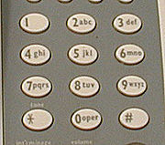

A DTMF Telephone Keypad

Page 17
DTMF Keypad Frequencies (With Sound Clips)

 | 1209 Hz | 1336 Hz | 1477 Hz | 1633 Hz
697 Hz | 1 | 2 | 3 | A
770 Hz | 4 | 5 | 6 | B
852 Hz | 7 | 8 | 9 | C
941 Hz | * | 0 | # | D

DTMF Event Frequencies

Event | Low Freq. | High Freq.
Busy Signal | 480 Hz | 620 Hz
Dial Tone | 350 Hz | 440 Hz
Ringback Tone(US) | 440 Hz | 480 Hz

Page18
Tones #, *, A, B, C, and D

The engineers had envisioned phones being used to access computers, and surveyed a number of companies to see what they would need for this role. This led to the addition of the number sign (#, sometimes called
!octothorpe! in this context) and asterisk or ’star’ (*) keys as
well as a group of keys for menu selection: A, B, C and D. In the end, the lettered keys were dropped from most phones, and it was many years before these keys became widely used for vertical service codes such as *67 in the United States and Canada to suppress caller ID.

The U.S. military also used the letters, relabeled, in their now defunct Autovon phone system. Here they were used before dialing the phone in order to give some calls priority, cutting in over existing calls if need be. The idea was to allow important traffic to get through every time. The levels of priority available were Flash Override (A), Flash (B), Immediate (C), and Priority (D), with Flash Override being the highest priority.

Page 19

PRLIMINARY DESIGN

Page 20
1. BLOCK DIAGRAM :

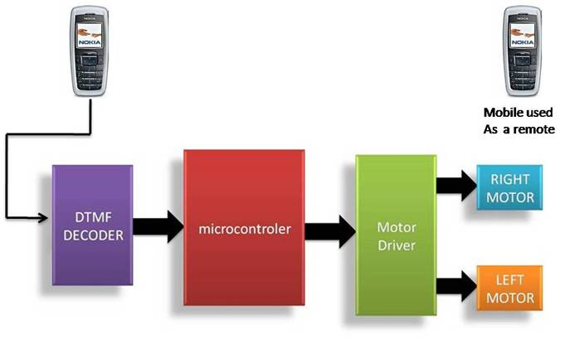

DESCRIPTION:

As shown in the above block diagram, first block

is the
Cell Phone. So,
it acts
as a DTMF generator
with tone

depending upon key
pressed. DTMF
Decoder ,i.e., IC CM8870

decodes the received tone & gives binary equivalent of it to the

microcontroller. The
controller is
programmed
such that

appropriate output is
given to Motor Driver IC L293D which

will drive the two DC Motors connected to it. The concept used for driving is ‘Differential Drive’. So, ultimately the two motors

rotate phone.
according to the key pressed
on the
keypad
of the
cell

Page 21

2. COMPONENTS USED:

1) RESISTORS: 2) CAPACITORS:

VALUE QUANTITY
100k | 2
10k | 5
330k | 1

VALUE QUANTITY
0.1 uF 2
22 pF 4

3) OSCILLATORS: 4)ICs:

VALUE QUANTITY
CM 8870 | 1
Atmega16 | 1
74ls04 | 1
L293D NE | 1
L7805 CV | 1

3.57 MHz 1
12 MHz 1
VALUE QUANTITY

5) MISCELLANEOUS:

COMPONENT | QUANTITY
12V ,50 RPM DC MOTOR | 2
DIODE, 4007 | 1
RESET SWITCH | 1
1.5V DC BATTERYs | 9
CONNECTING WIRES | 7

Page 22

3. CIRCUIT DIAGRAM :

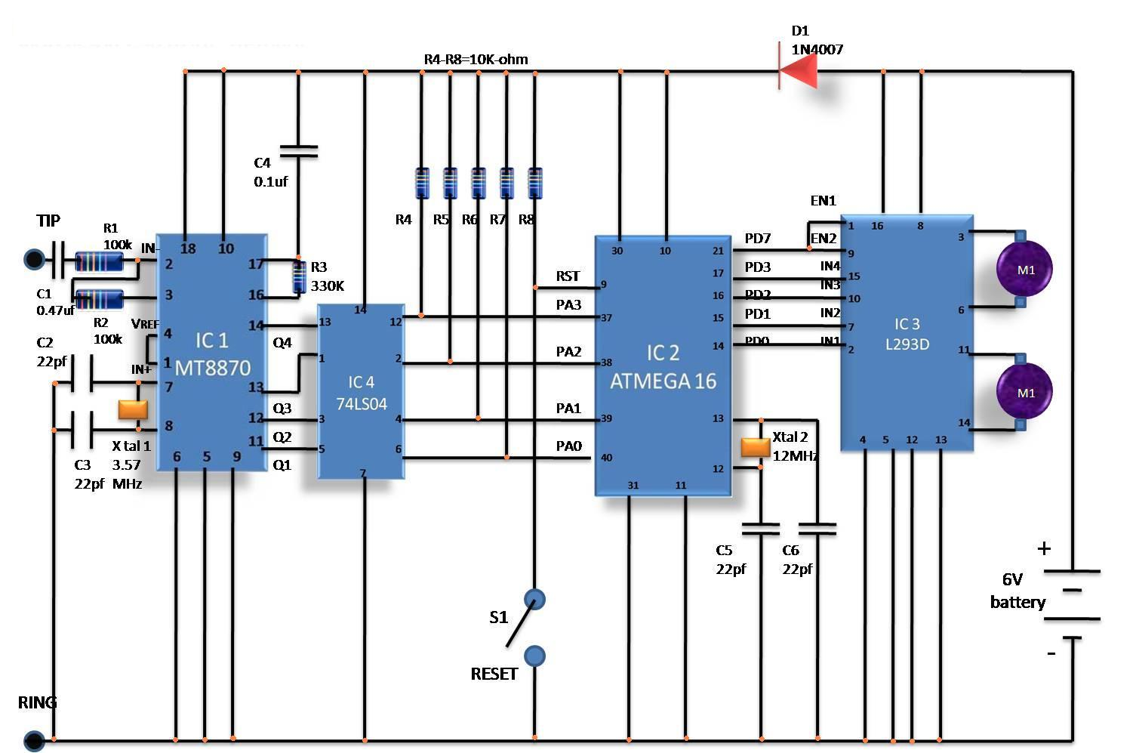

Page 23

PROBLEMS

ENCOUNTERED

Page 26
PROBLEMS FACED :

Although the concept & design of the project seemed perfect, there were some problems faced while actual implementation:

1. Connecting HandsFree of cell phone to DTMF
decoder IC input:

There were several types of HandsFree cords available in the market, the right one had to be chosen from them. Several ways to break up the cords and connect them to the input of IC 8870 were tried & some were newly developed by us (e.g. Connecting Audio Jack of PC!s speakers to the cell
phone with help of an extender).

Solution:

Finally HandsFree cord!s !Earplugs! were

removed & resulting set of wires were connected in an appropriate manner to the Decoder IC!s input.

Page 27

2. Selection of Mobile Phone:

At first, latest cell phone like Nokia 5700, N-series were tried. But they couldn!t give any output. Several
cell phones were tested with their respective Hansfree cords.

Solution:

The older version phones like Nokia 1100,Nokia

2300 were found to be more suitable for the purpose. Finally
Nokia 1100 was used.

Page 28

FINAL DESIGN

Page 29

FINAL
DESIGN :

1. PCB LAYOUT :

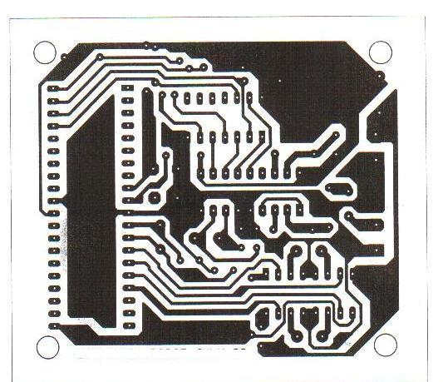

Page 30

2. CIRCUIT DESCRIPTION :

The important components of this robot are a DTMF decoder, microcontroller and motor driver.

A CM8870 series DTMF decoder is used here. All types of the CM8870 series use digital counting techniques to detect and decode all the 16 DTMF tone pairs into a 4-bit code output. The built-in dial tone rejection circuit eliminates the need of pre-filtering.

When the input signals are given at pins 1(IN+)
& 2(IN-) , a differential input configuration is recognized to be effective, the correct 4-bit decode signal of the DTMF tone is transferred to (pin11) through (pin14) outputs. The pin11 to pin14 of DTMF decoder are connected to the pins of microcontroller (P1.4 to P1.7).

The atmega16 is a 8-bit microcontrol, has
64 kB Flash microcontroller with 1 kB RAM. it provides the following features: 64 kB of on-chip Flash program memory with ISP (In-System Programming) and IAP (In-Application Programming), Four 8-bit I/O ports with three high-current
Port 1 pins (16 mA each),Three 16-bit timers/counters.

Page 24

Outputs from port pins P0.0 through P0.3 and P0.7 of the microcontroller are fed to the inputs IN1 through IN4 and enable pins (EN1 and EN2) of motor driver L293D IC, respectively to drive two geared dc motors. Switch S1 is used for manual reset. The microcontroller output is not sufficient to drive the dc motors, so current drivers are required for motor rotation.

The L293D is a quad, high-current, half-h driver designed to provide bidirectional drive currents of up to
600mA at voltages from 4.5V to 36V. It makes it easier to drive the dc motors. The L293D consists of four drivers. Pins IN1 through IN4 and OUT1 through OUT4 are the input and output pins, respectively of driver 1 through driver 4. Drivers 1 and 2, and driver 3 and 4 are enabled by enable pin 1(EN1) and pin 9 (EN2), respectively. When enable input EN1 (pin1) is high, drivers 1 and 2 are enabled and the outputs corresponding to their inputs are active. Similarly, enable input EN2 (pin9) enables drivers 3 and 4.

The motors are rotated according to the status of IN1 to IN4 pins of L293D which in turn are depending on
output pins of microcontroller, viz., P0.0 - P0.3.

Page 25
3. PROGRAM CODE : FILENAME: Project_Final.asm
; CELL PHONE OPERATED LAND ROVER

;P1.4-P1.7 ---> atmega16 i/p ---> Connected to DTMF o/p

;P0.0-P0.3 ---> atmega16 o/p ---> Connected to L293D

org 0000h

mov p1,#0ffh ; Make P1 as i/p port

L1: mov a,p1 anl a,#0ffh

cjne a,#0b0h,L2 ;DTMF o/p= 2

mov p0,#8ah ;M1 & M2 both Forward

Page 31
ljmp L1

L2: cjne a,#0e0h,L3 ;DTMF o/p= 8

mov p0,#85h ;M1 & M2 both Reverse ljmp L1

L3: cjne a,#50h,L4 ;DTMF o/p= 5 mov p0,#80h ;M1 & M2 both Off ljmp L1

L4: cjne a,#0d0h,L5 ;DTMF o/p= 4

mov p0,#86h ;M1 = Rev , M2 = Fwd ljmp L1

L5: cjne a,#90h,L1 ;DTMF o/p= 6
mov p0,#89h ;M1 = Fwd , M2 = Rev ljmp L1

end

Page 32
4. FLOWCHART

START

READ THE INPUT FROM DTMF
DECODER (PORT 1)

IF INPUT=2
M1=FWD

M2=FWD
CALL APPROPRIATE
DELAY

IF INPUT=8
M1=REV

M2=REV
CALL APPROPRIATE
DELAY

IF INPUT=5
M1=STOP

M2=STOP
CALL APPROPRIATE
DELAY

IF INPUT=4
M1=REV

M2=FWD
CALL APPROPRIATE
DELAY

IF INPUT=6
M1=FWD

M2=REV
CALL APPROPRIATE
DELAY

Page 33

SOFTWARES USED

Page34

APPLICATIONS

Page 40
APPLICATIONS :

Scientific

Remote control vehicles have various scientific

uses including hazardous environments, working in the deep ocean , and space exploration. The majority of the probes to the other planets in our solar system have been remote control vehicles, although some of the more recent ones were partially autonomous. The sophistication of these devices has fueled greater debate on the need for manned spaceflight and exploration. The Voyager I spacecraft is the first craft of any kind to leave the solar system. The martian explorers Spirit and Opportunity have provided continuous data about the surface of Mars since January 3, 2004.

Military and Law Enforcement

Military usage of remotely controlled military vehicles dates back to the first half of 20th century. Soviet Red Army used remotely controlled Teletanks during 1930s in the
Winter War and early stage of World War II. There were also

Page 41

remotely controlled cutters and experimental remotely controlled planes in the Red Army.

Remote control vehicles are used in law enforcement and military engagements for some of the same reasons. The exposure to hazards are mitigated to the person who operates the vehicle from a location of relative safety. Remote controlled vehicles are used by many police department bomb-squads to defuse or detonate explosives. See Dragon Runner, Military robot.

Unmanned Aerial Vehicles (UAVs) have undergone a dramatic evolution in capability in the past decade. Early UAV!s were capable of reconnaissance missions alone and then only with a limited range. Current UAV!s can hover around possible targets until they are positively identified before releasing their payload of weaponry. Backpack sized UAV!s will provide ground troops with over
the horizon surveillance capabilities.

Page 42
Search and Rescue

UAVs will likely play an increased role in search and rescue in the United States. This was demonstrated by the successful use of UAVs during the 2008 hurricanes that struck Louisiana and Texas.

Recreation and Hobby

See Radio-controlled model. Small scale remote control vehicles have long been popular among hobbyists. These remote controlled vehicles span a wide range in terms of price and sophistication. There are many types of radio controlled vehicles. These include on-road cars, off-road trucks, boats, airplanes, and even helicopters. The ’robots’ now popular in television shows such as Robot Wars, are a recent extension of this hobby (these vehicles do not meet the classical definition of a robot; they are remotely controlled by
a human). Radio-controlled submarine also exist.

Page 43

FURTHER IMROVEMENTS

FUTURE SCOPE

Page 44
FURTHER IMPROVEMENTS & FUTURE SCOPE :

1. IR Sensors:

IR sensors can be used to automatically detect & avoid obstacles if the robot goes beyond line of sight. This avoids damage to the vehicle if we are maneuvering it from a distant place.

2. Password Protection:

Project can be modified in order to password protect the robot so that it can be operated only if correct password is entered. Either cell phone should be password protected or necessary modification should be made in the assembly language code. This introduces conditioned access &
increases security to a great extent.

Page 45
3. Alarm Phone Dialer:

By replacing DTMF Decoder IC CM8870 by a
!DTMF Transceiver IC’ CM8880, DTMF tones can be generated from the robot. So, a project called !Alarm Phone Dialer! can be built which will generate necessary alarms for something that is desired to be monitored (usually by triggering a relay). For example, a high water alarm, low temperature alarm, opening of back window, garage door, etc.

When the system is activated it will call a number of programmed numbers to let the user know the alarm has been activated. This would be great to get alerts of alarm conditions from home when user is at work.

4. Adding a Camera:

If the current project is interfaced with a camera (e.g. a Webcam) robot can be driven beyond line-of-sight & range becomes practically unlimited as GSM networks have a
very large range.

Page 46

BIBLIOGRAPHY

Page 47
BIBLIOGRAPHY:

1. Wikipedia - The free encyclopedia

2. http://www.8051projects.info/

3. http://www.instructables.com/

4. cell phone operated land rover Electronics For You’ Magazine , Edition (july 2008)

5. “DTMF Tester” , ‘Electronics For You’ Magazine , Edition
(June 2003)

6. http://www.alldatasheet.com/

7. http://www.datasheet4u.com/

8. http://www.datasheetcatalog.com/

Page 48

DATASHEETS

Page 49

PINNACLE ENVIROMENT:

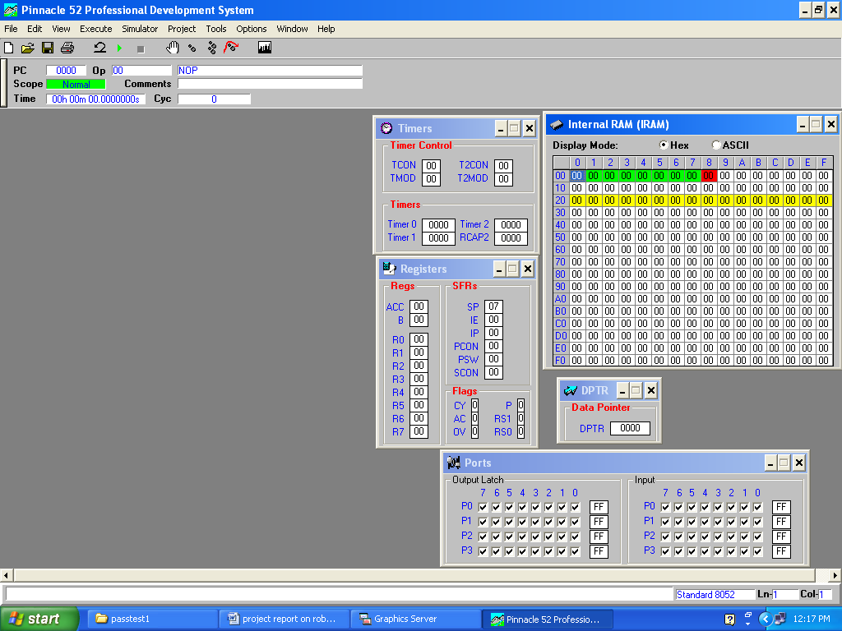

AVR SPI PROGMMER:
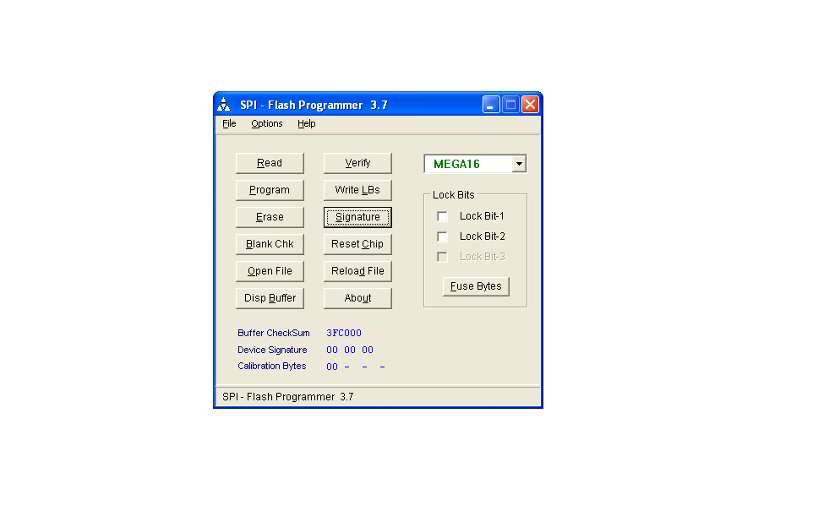
Page 35

ADVANTAGES

Page 36

- Wireless control

2. Surveillance System.

3. Vehicle Navigation with use of 3G technology.

3. Takes in use of the mobile technology which is almost available everywhere.

4. This wireless device has no boundation of range and can be controlled as far as network of cell phone

Page 37

DISADVANTAGES

page38

- Cell phone bill.

2. Mobile batteries drain out early so charging problem.

3. Cost of project if Cell phone cost included.

4. Not flexible with all cell phones as only a particular ,cell phone whose earpiece is attached can only be used

Page 39

Page 50

